**CONTENT/TEXT GENERATION**

The supplied code empowers the model to adeptly predict and generate text in alignment with the provided input context. Furthermore, the interface employed for text input is remarkably user-friendly and intuitively accessible. Notably, the model also exhibits the capability to rectify grammatical errors within the given input while preserving the user's original style and tone.

**Example:** Screenshot of the model behavior for a particular input text and text length

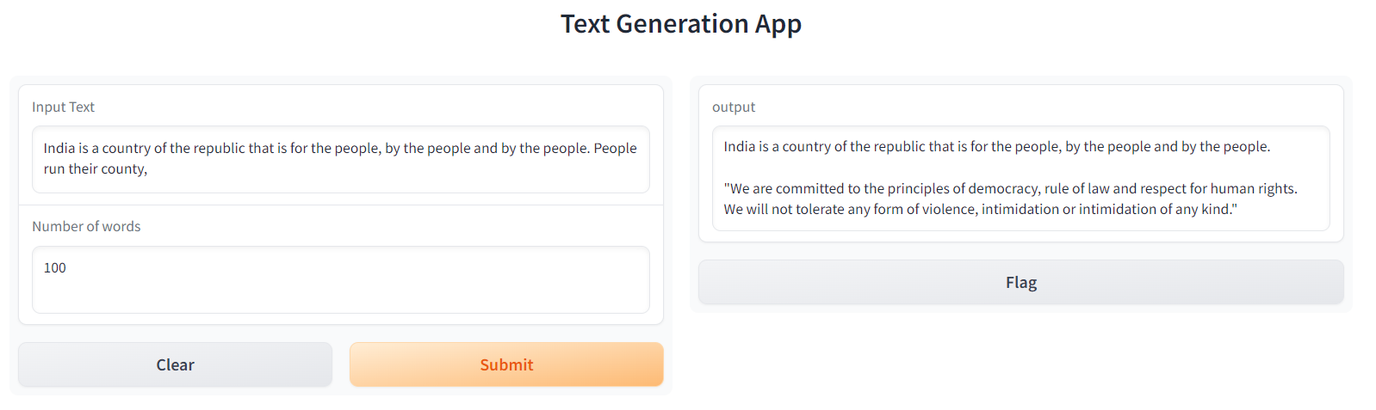

**Future Scope:**

1. The model's output delivery exhibits a certain level of delay. Enhancing the model's response time can be achieved through the refinement of its parameters.

2. On occasions, the generated content slightly deviates from perfect alignment with the input text. This situation can be mitigated by training the model on an expansive dataset and furnishing it with context-specific input text.

3. There is room for enhancement in the user interface as well.